http://krebsnhs.weebly.com/
Equipment:

1 x 3M Coban 2 Inner Comfort Layer 10cm x 3.5M (1 on packet)
Order ref number 1 box x 18 rolls: 3M code: 20014 NPC code: ECA210
1 x 3M Coban 2 Compression Layer 10cm x 4.5M (2 on packet)
Order ref number 1 box x 32 rolls: 3M code: 20024 NPC code: ECA214
Micropore Tape
Scissors

Technique:

Following application of an adhesive dressing over the surgical site the non-sterile Coban 2 Inner comfort layer (1) can be applied.
This can be started with or without the tourniquet being inflated and the foot should be in a slightly dorsi-flexed position to aid ankle articulation following application.
Start at the foot, just above toe line and wrap proximally. The foam layer (white) is positioned against the skin.
Avoid wrapping the plantar aspect of the heel. This reduces bulk and allows normal footwear to be worn. (Fig 1)
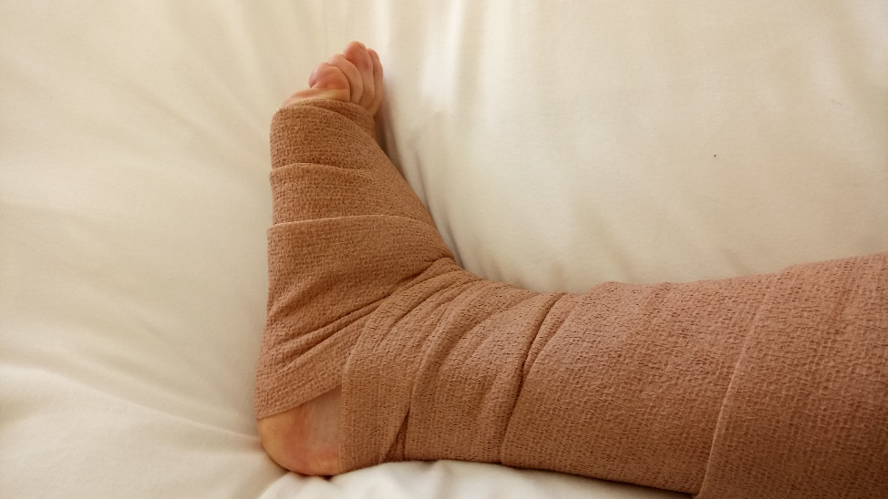fig 1.
This layer should be put on with minimal tension and approximately 10-20% overlap enabling minimal bulk. This layer often looks untidy.
When you reach the mid-thigh level trim the remaining bandage and secure the flap with tape.
Next, apply Coban 2 Compression Layer (2).
Start at the foot (metatarsal heads) ensuring there is a small amount of Comfort layer left free. Fig 2
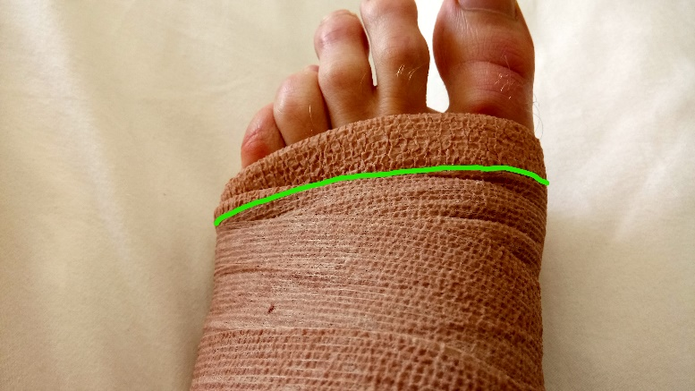fig 2.
Now wrap the foot including heel area. Stretch the Coban 2 from its resting state but not up to the ‘locked out’ tension (i, ii, iii)
To prevent dog ears and flaps utilise a further throw back around the foot before working proximally up the leg.
Ensure that the Compression layer is stretched and applied with a 50% overlap. This allows the bandage to compress. If you miss a bit, simply re-wrap and double over. (fig 3.)
Be mindful not to over stretch, for this study we are preventing swelling post-op, rather than compressing excess fluid pathology such as lymphoedema. Aim to stretch this layer between its wrapped (i) and locked-out (ii) tension as highlighted in the accompanying videos.

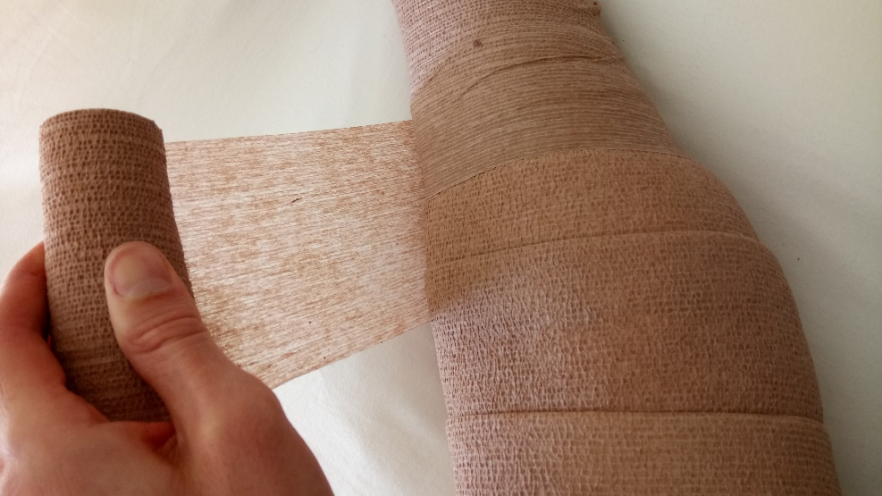
Wrap the rest of leg leaving a small amount of Comfort layer uncovered around the thigh. Trim the remaining bandage using scissors.
Finally, pat down and smooth the compression layer onto the leg to ensure good adhesion to layer 1
The aim is to keep the bandage in-situ for 48hrs. It must be removed prior to discharge. Time of removal should be noted in the medical/nursing notes and if removed before 24hrs the reason why must also be stated.

Fig 3.
Removal:

For removal, simply use a pair of blunt nosed scissors and cut the bandage on the front of the leg taking care of the underlying skin. This can be done both proximally and distally. Remove the bandage.

- Coban 2 compression layer- unstretched
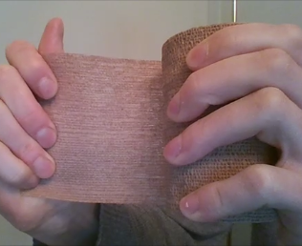

- Coban 2 compression layer- Stretched/locked out
Aim to stretch this layer between its wrapped (i)
and locked-out (ii) tension
